Come to Peterborough and the Kawartha’s, where the beauty is breath taking. Let us help you build a package that will provide your passengers an experience they will never forget!

2 Hour Liftlock Sightseeing Cruise
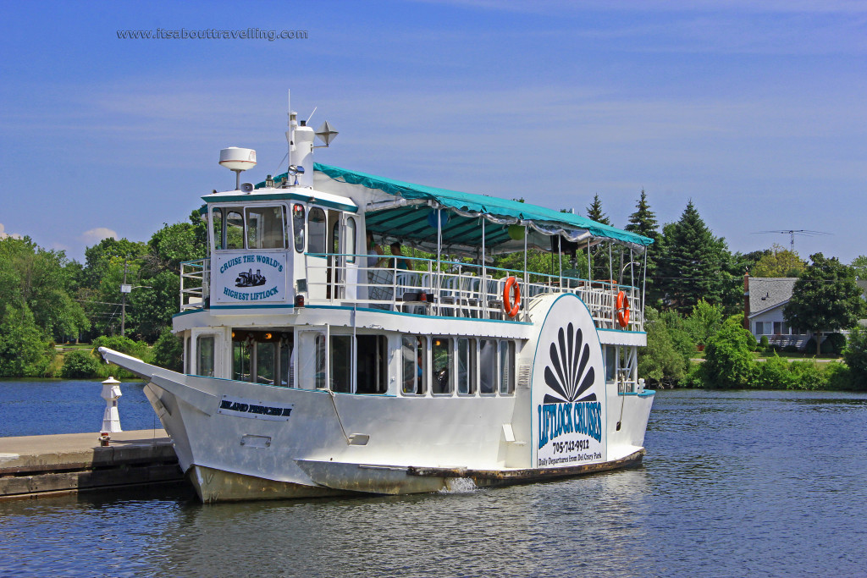
Climb aboard and cruise over the famous, world’s largest hydraulic Liftlock, a 65 foot lift. Our Captain will give you a humorous and informative commentary of the waterway and how the locks work while entertaining you with stories of the area of days gone by. Turn your sightseeing cruise into a Luncheon cruise and enjoy a delicious meal catered by Franz, Peterborough’s own, butcher shop.

Turn your sightseeing cruise into a Luncheon cruise and enjoy a delicious meal catered by Peterborough’s own;

Meal Options: * 1 option Choice for everybody on the cruise* Plus taxes and Gratuity

A) Boneless chicken breast served with caesar salad, dinner rolls with butter, bean melody, roasted potatoes, seasonal pie and coffee/tea

B) Roast Beef with gravy served with garden salad, dinner rolls with butter, green beans, roasted potatoes, seasonal pie and coffee/tea

*All package pricing are based on Monday to Friday Bookings
**Weekend Bookings are subject to availability, pricing will be based on a per booking basis

#2: Musical Luncheon Cruise

Cruise with one of Peterborough’s own musical talented artist! While you relax with live entertainment you can enjoy a scrumptious meal served right to your table as we travel up and over the world’s largest hydraulic Liftlock, a 65 foot lift.

#3: Sightseeing or Luncheon Cruise with Kawartha Downs Casino Package
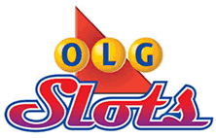
Enjoy the sights as we cruise up the Trent Severn Waterway to our world’s highest hydraulic Liftlock, a 65 foot lift. You can customize your cruise by adding lunch. Our Captain will explain to you through his commentary the history of the waterway and how the locks work while entertaining you with stories of the area of days gone by. Then you will be whisked away to the Kawartha Downs for 3 hours of casino entertainment. Each participant will receive a $10.00 value in tokens. Must be 19 years of age or older.
*Some restrictions may apply
*Groups must be OLG approved
Sightseeing Cruise = FREE *Weekend bookings subject to a premium of $5/person
Luncheon Cruise = $27.50 Weekdays only

*All package pricing are based on Monday to Friday Bookings
**Weekend Bookings are subject to availability, pricing will be based on a per booking basis

Triple Crown Fall Colours Cruises

The Otonabee River is well known for its inspiration and the creative literary works of Susanna Moodie and Cathryn Parr Traill in 1800’s. These two English born, Canadian authors’ wrote “Roughing it in the Bush” in 1852 and “Back Woods of Canada,” in 1836 which is about their new lives at settlers to Canada. The Otonabee River captivates the beauty of Ontario.

Southbound
Departing from Lock 19, Peterborough, we’ll travel southbound on the Otonabee River, 30km (approx. 18miles) to Gore’s Landing, a century old Country Inn on Rice Lake. Sit back and relax on this cruise, with live entertainment. This 3 hour cruise highlights, a delicious menu, delightful sounds of live music and spectacular Fall Colours. This is a limited time offer, starting on September 24th until the end of our cruising season. Add a post-cruise lunch at the Victoria Inn for $20/person
Departure Time: 10:00am or early morning

Northbound
Departing from Gore’s Landing at the Historical Victoria Inn, this cruise will travel Northbound up the Trent Severn Waterway to Lock 19. Sit back and relax with live musical entertainment while you enjoy the scenic fall colours on the beautiful Rice Lake and the inspirational Otonabee River. This 3 hour cruise is served with coffee or tea and pastries. Starting on September 24th until the end of cruising season is a limited time offer. Add a pre-cruise lunch at the Victoria Inn for $20/person

Departure Time: 1:30pm or early afternoon

A Minimum of 40 people is required
*All package pricing are based on Monday to Friday Bookings
**Weekend Bookings are subject to availability, pricing will be based on a per booking basis

